National Cheng Kung University
Department of Electrical Engineering

Introduction to VLSI CAD (Spring 2016)

Lab Session 6

Design of Finite State Machines and Controllers

Name | Student ID
Practical |  | Points | Marks
Lab A |  | 10
Lab B |  | 15
Lab C |  | 25
Lab D |  | 50
Notes

Due: 15:00 April 20, 2016 @ moodle

Deliverables
- All Verilog codes including testbenches for each problem should be uploaded.
NOTE: Please DO NOT include source code in the paper report!
- All homework requirements should be uploaded in this file hierarchy.
- NOTE: 1. Please DO NOT upload waveforms!
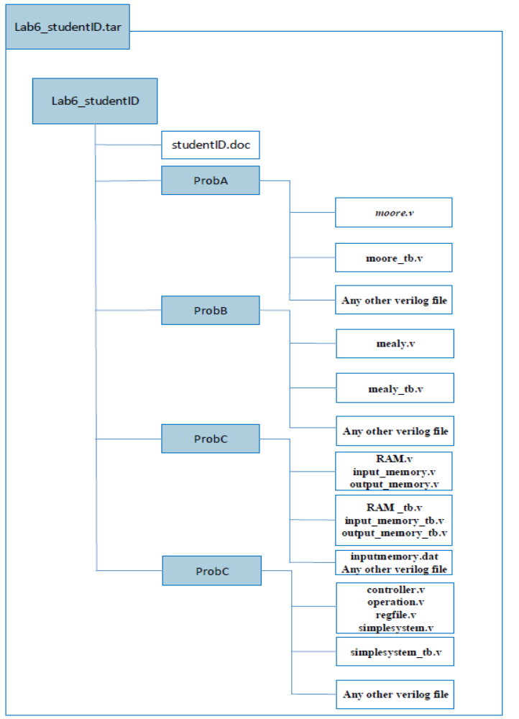

Fig.1 File hierarchy for Homework submission
Objectives:
To learn how to design the finite state machine and the mini system.
Prob A: Moore Machine
- Observe the given state diagram
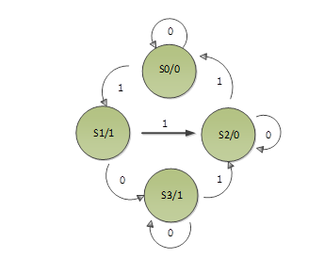

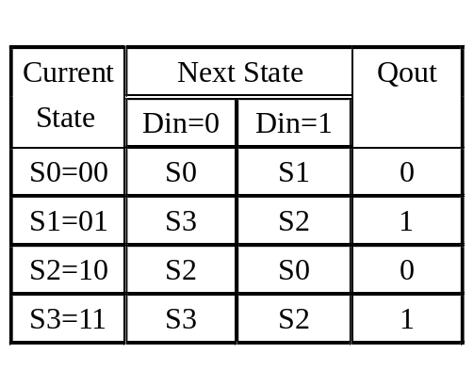

Table1. Moore state table

- Write Verilog code for this FSM based on the Moore Machine. And you should name all your I/O ports according to the naming specification.

Port name | input/output | # bit
rst | input | 1
clk | input | 1
din | input | 1
qout | output | 1
Table2. I/O Naming Specification

- Compile the verilog code and write a testbench to verify the operations of this module works properly.

- Please attach your waveforms and specify your operations on the waveforms.
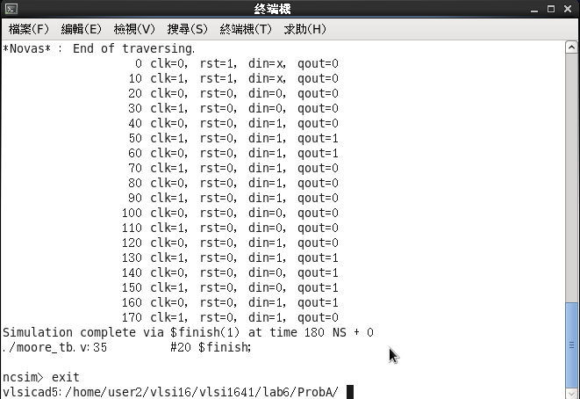
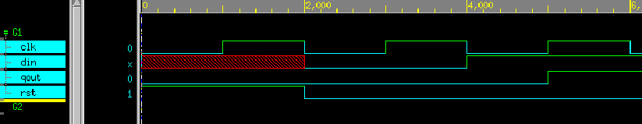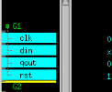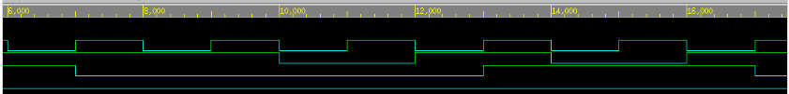

先用reset去重製所有的port
當s0時,輸入din為1時就會跑到s1 , 輸入din為0時就會跑到s0,qout為0
當s1時,輸入din為1時就會跑到s2 , 輸入din為0時就會跑到s3,qout為1
當s2時,輸入din為1時就會跑到s0 , 輸入din為0時就會跑到s2,qout為0
當s3時,輸入din為1時就會跑到s2 , 輸入din為0時就會跑到s3,qout為1
故波形剛開始時在so, 輸入din為1就會跑到s1, qout為0 ,再輸入din為1就會跑到s2 , qout為1, 再輸入din為1就會跑到s0 , qout為0,以此類推下去

Prob B: Mealy Machine
- Observe the given state diagram

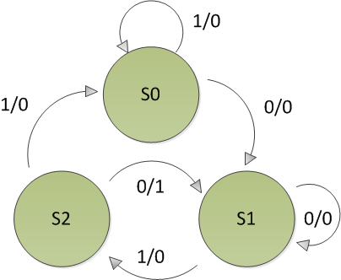

Current State | Next State
Current State | din=0 | din=1
S0=00 | S1,0 | S0,0
S1=01 | S1,0 | S2,0
S2=11 | S1,1 | S0,0

Table3. Construct the state table

- Write Verilog code for this FSM based on the Mealy Machine. When the System detecting sequence of 010 from input data, qout will be flagged to logic 1. You should name all your I/O ports according to the naming specification.

Port name | input/output | # bit
rst | input | 1
clk | input | 1
din | input | 1
qout | output | 1
Table4. I/O Naming Specification

- Compile the verilog code and write a testbench to verify the operations of this module works properly.

- Please attach your waveforms and specify your operations on the waveforms.

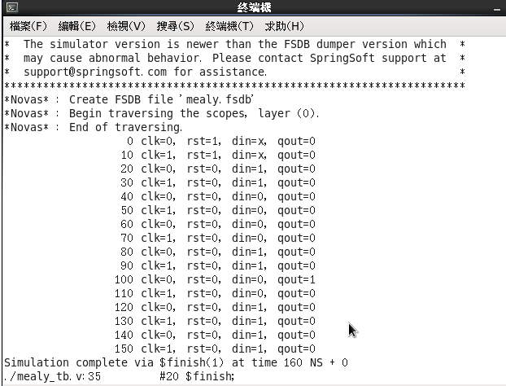
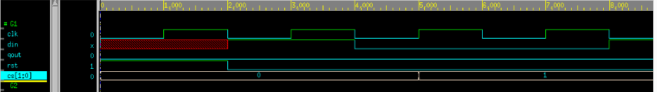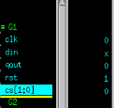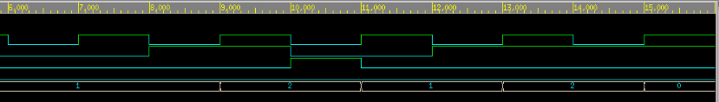
先用reset去重製所有的port
當s0時,輸入din為1時就會跑到s1,qout為0 , 輸入din為0時就會跑到s0,qout為0
當s1時,輸入din為1時就會跑到s1 ,qout為0, 輸入din為0時就會跑到s2,qout為0
當s2時,輸入din為1時就會跑到s1 ,qout為1, 輸入din為0時就會跑到s0,qout為0
故波形剛開始時在so, 輸入din為1就會跑到s0, qout為0 ,再輸入din為0就會跑到s1 , qout為0, 再輸入din為1就會跑到s2 , qout為0, 再輸入din為0就會跑到s1 , qout為1,以此類推下去

Prob C: Memory
- Understand the function of memory
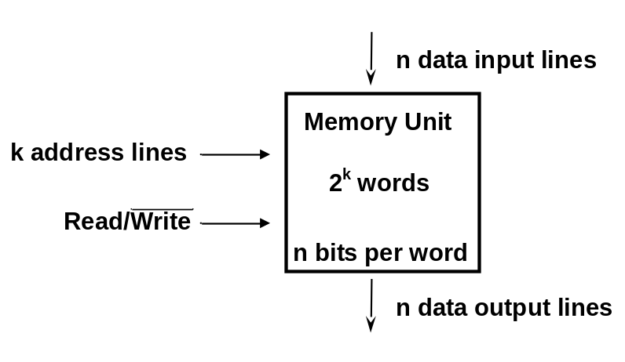
Please fill the blanks :
- Memory is a collection of storage cell together with associated circuits needed to transfer information
- During write operation, a specific word is selected by applying k-bit address and the selected word will be put on Data Output
- During read operation, the input address selects the memory location to be written with the data appear at the Data Input

- Design a 64x32 bits Memory which consists of :
- Data depth = 64, Data width = 32,
- Working at positive edge of clock
- When en_write is high, the DMin is stored into the memory as pointed by addr. When en_read is high, the data will be put on DMout as pointed by addr.
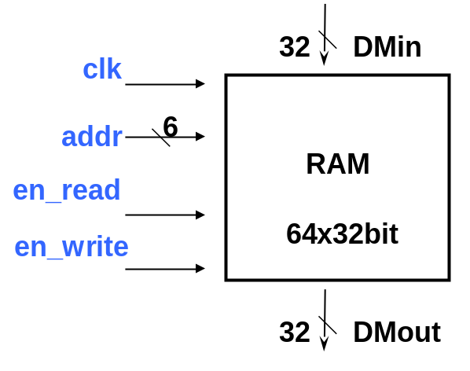
- Compile the RAM code and write a testbench to observe the operation of this module using the following rules (All data value is hex ):
- Write data (0x0000_0afc, 0x0000_b031, 0xf000_0005, 0x0000_0246, 0x0000_00a9, 0x0000_006e, 0xffff_ffff, 0x0000_046a, 0x03c1_0dd3) into addr (0, 31, 4, 7, 9, 6, 40, 37, 63 ) (dec).
- Read data from addr (2, 3, 57, 11, 40, 19, 63, 31) (dec).
- Write data (0x0000_0FF5, 0x00ed_2a24) into addr (3, 17) (dec).
- Read data from addr (3) (dec).
- Write data (0x0000_0123) into addr (19) (dec).
- Read data from addr (17) (dec).
- Write data (0x0000_0ccc) into addr (1) (dec).
- Read data from addr (1, 19) (dec).

- Please attach your waveforms and specify your operations on the waveforms.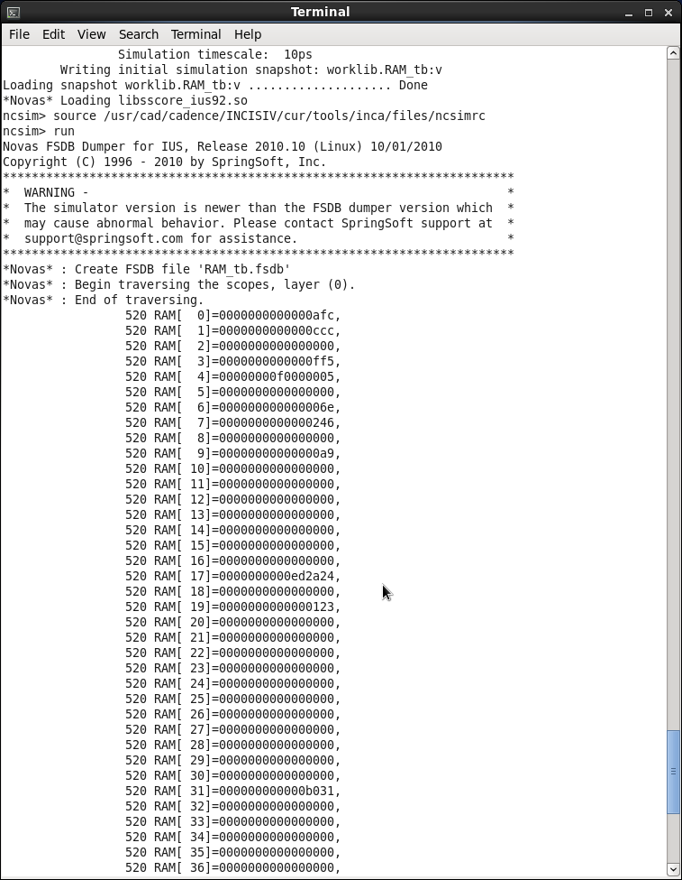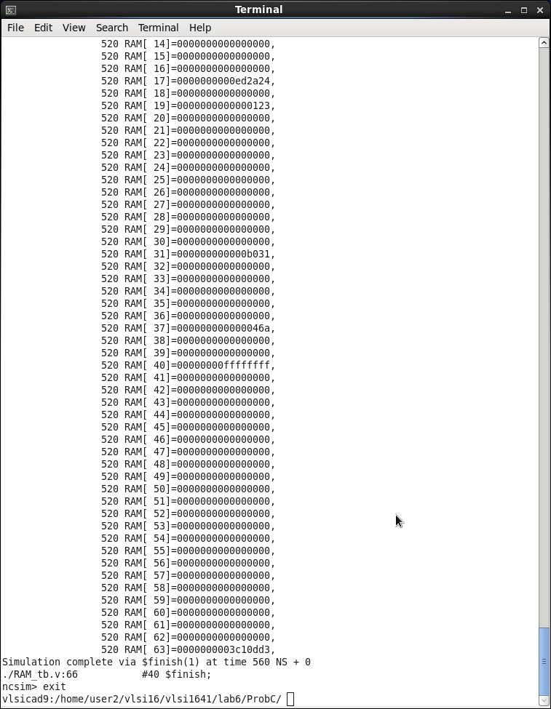
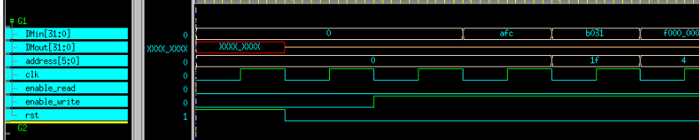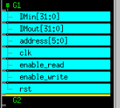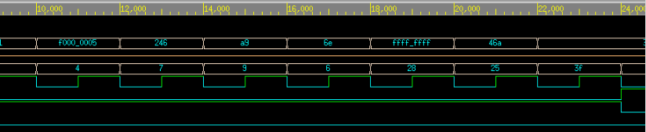
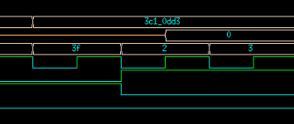
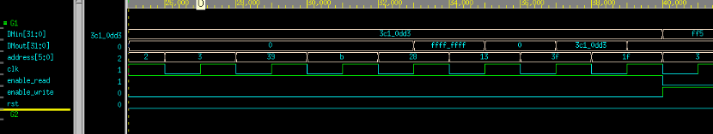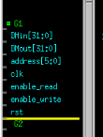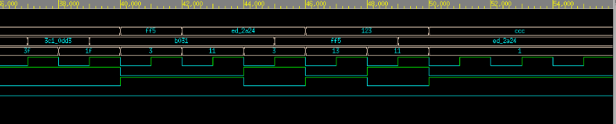
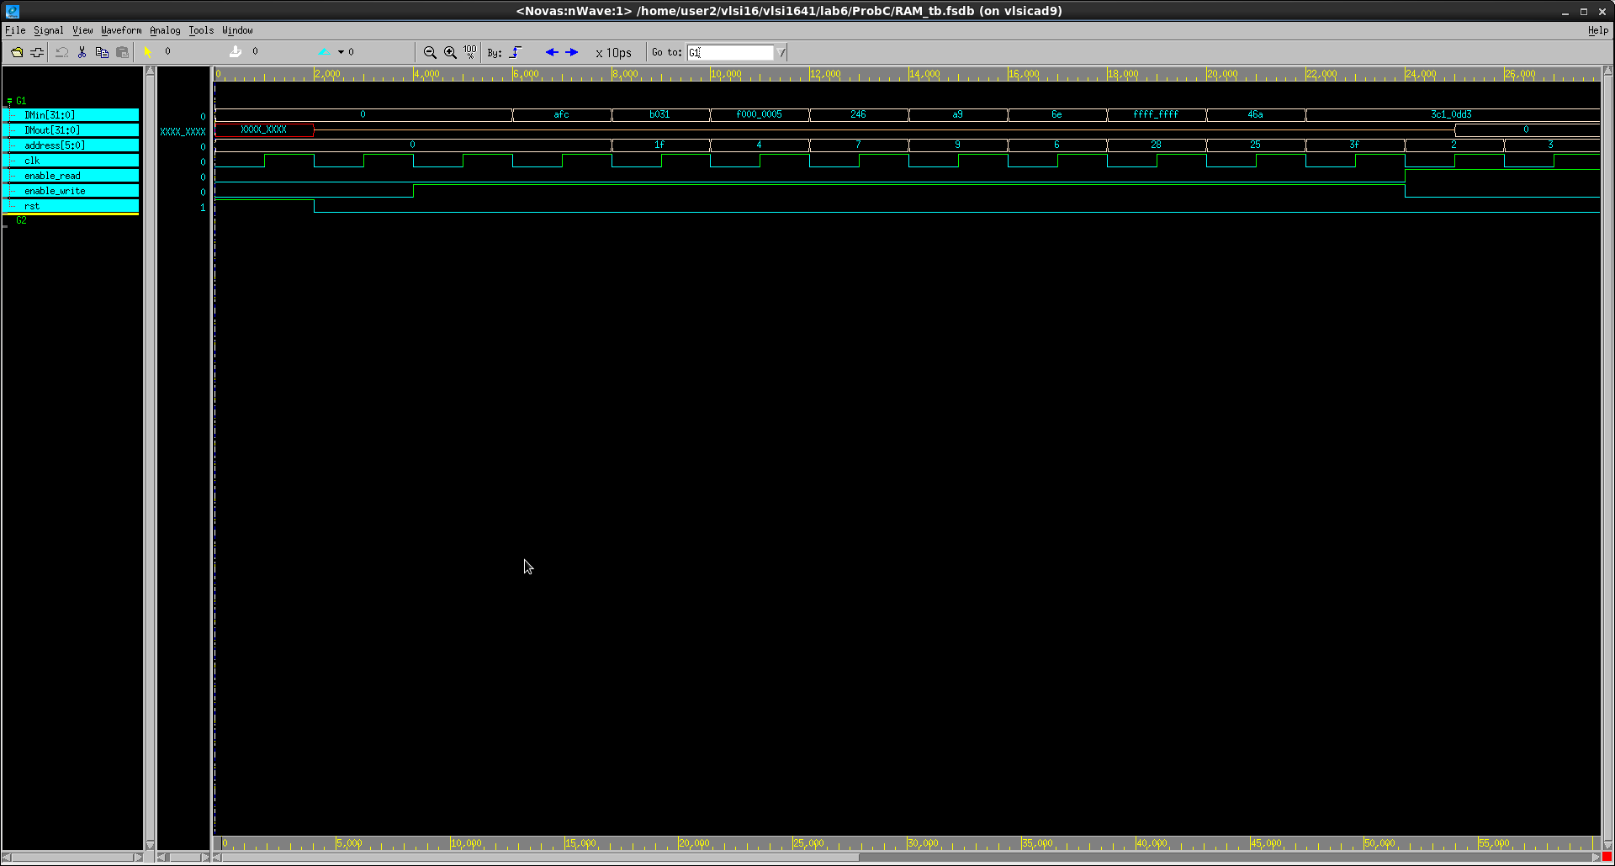
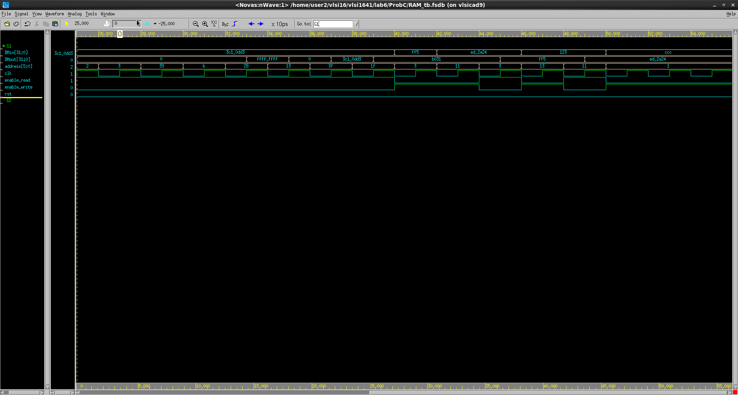
先用reset去重製所有的port
當en_write為1時,就開始將輸入的值,寫入相對應的addr中
當en_read為1時,就開始將輸入的值,呼叫相對應的addr,到out中
剛開始時, en_write為1, 就將0000_0afc寫入addr1中, 將0000_b031入addr31中 ,以此類推,之後en_read為1時, 開始read,將addr2…..的讓它顯示在out上 ,之後動作都一樣的原理

- Design two special memory blocks needed in Lab D.
The memory design has the following specifications:
Input_memory:
- Data depth = 64, Data width = 32
- One read address port and one data output ports
- When enable is high the data will be put on OutData as pointed by addr.
Output_memory:
- Data depth = 64, Data width = 32
- When rst is asserted, data values in all memory are reset to zero
- One write address port and one write data port
- When enable is high the data is stored into the memory as pointed by addr

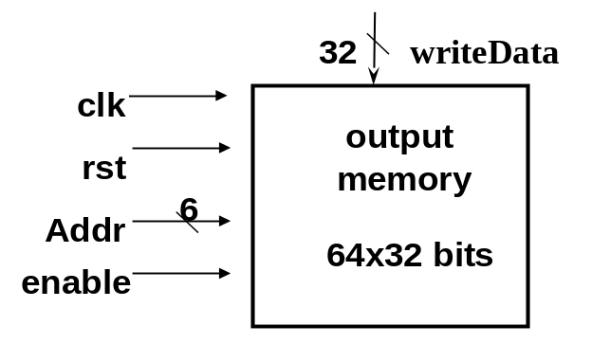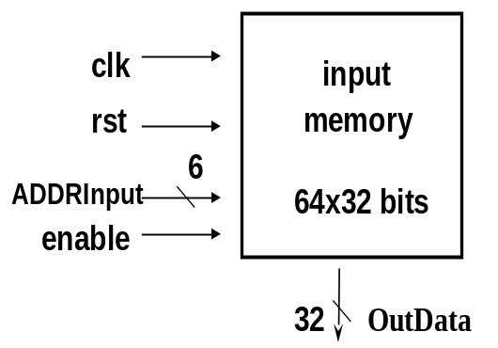

- Compile the Verilog code and write a testbench based on the conditions to prove that the operations of this module work properly:
Input_memory :
- Write a inmemory.dat according to following list and then load the inputmemory.dat into input_memory module. Please read data from addr 0~63.
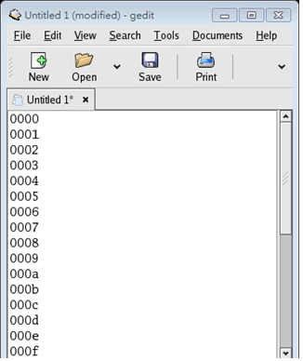
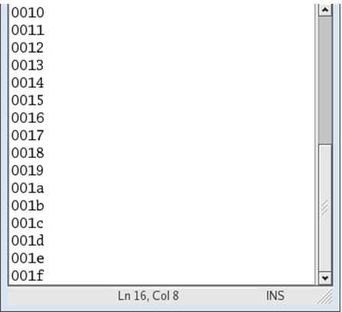

Output_memory :
- write data (1, 21, 30, 12, 17, 31, 2, 5, 20)(dec) into addr ( 1, 21, 30,42, 17, 31, 2, 55, 20 ) (dec) when enable = 1. then write data (4, 15, 29, 16) (dec) into addr (4, 45, 29, 16) (dec) when enable = 0. Finally write data (3, 6, 31, 12) (dec) into addr (3, 6, 31, 12) (dec) when enable = 1.

- Please attach your waveforms and specify your operations on the waveforms.
Input:
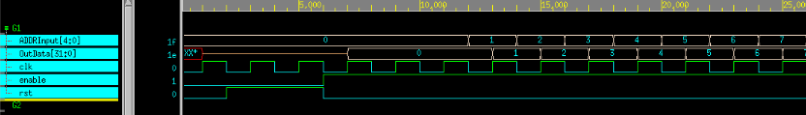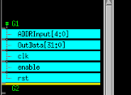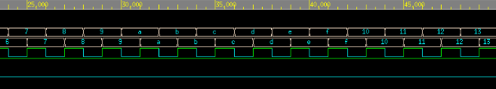
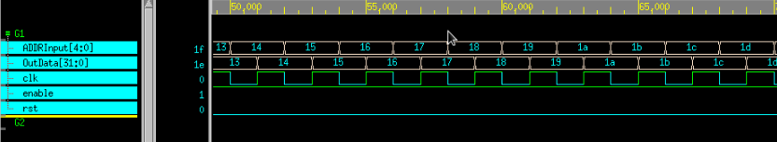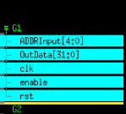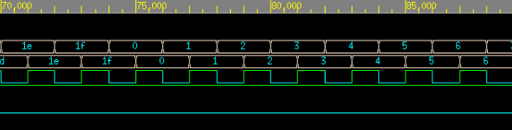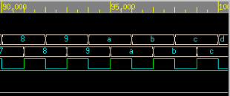

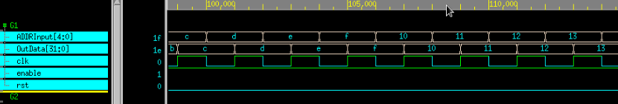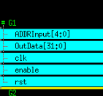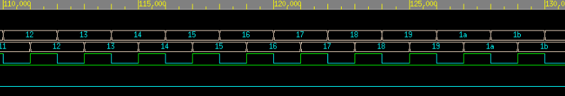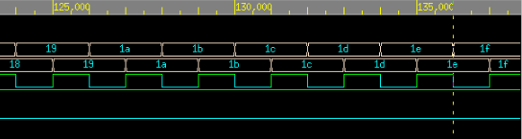
先用reset去重製所有的port
當enable為1時將outdata存入addrinput中

Output:
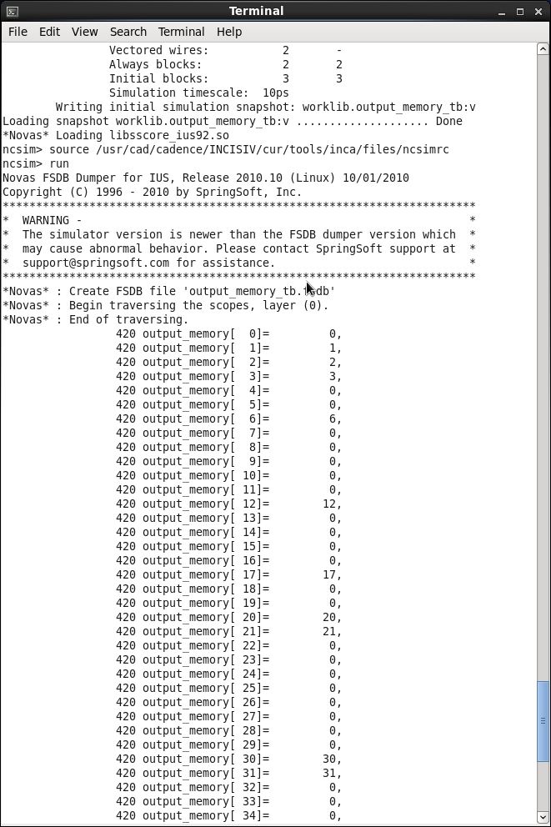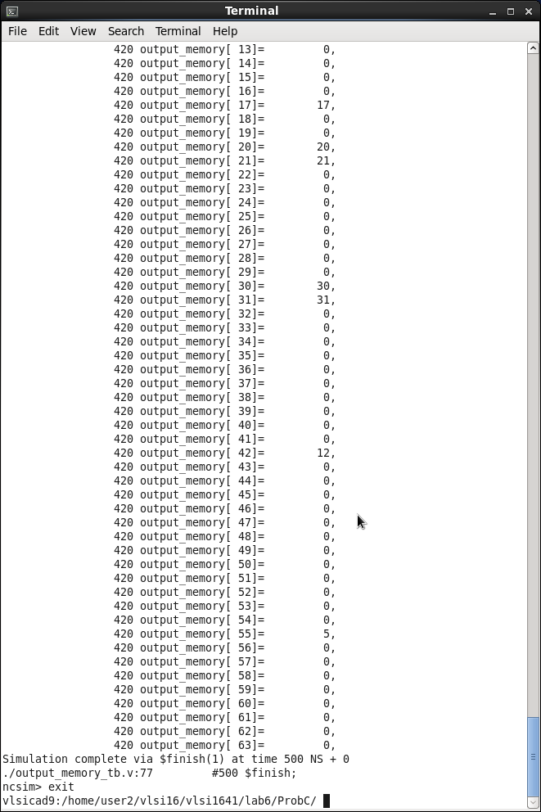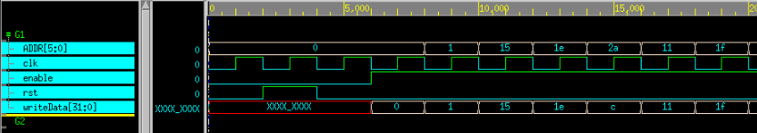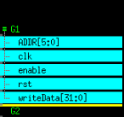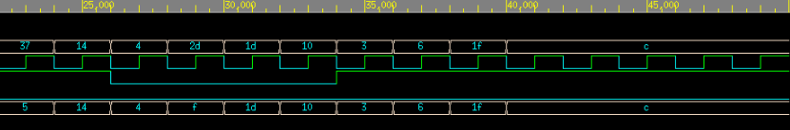
先用reset去重製所有的port
當enable為1時將addr中寫入writedata
Prob D: A mini system
You are about to integrate all components that you have learned so far to form a mini system (simplesystem). The simplesystem will be the framework for your final design lab. The block diagram of simplesystem is as shown in Fig1.
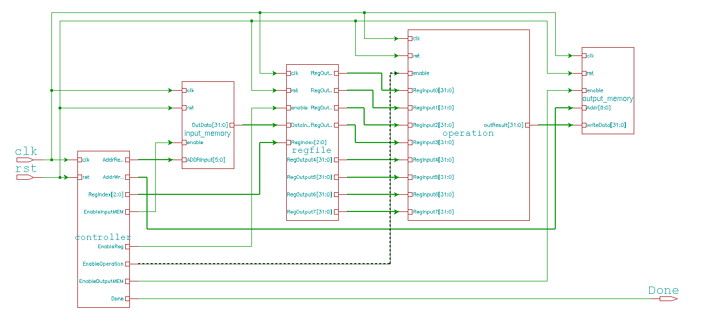
Fig1. The block diagram of simplesystem

- Understanding the function:
Once simplesystem is initialized, it
  - reads data from the input memory 8 times;
  - stores in the register file;
  - uses operation component to compute the maximum of the 8 numbers stored in the register file;
  - then outputs the maximum of the 8 numbers to the output memory(truncated to integer)
  - repeats the process step (a)-(d) for 8 times(means ALL data in input_memory, i.e., addr0-7, addr8-15, …, addr56-63)
  - flags “Done” when step (e) is completed

- Know the basic design rules
  - All operations initiated on the positive edge trigger of the clock
  - Control signals:
    - EnableInputMEM: To read data from input memory
    - EnableReg: To store the data from input memory to Register file
    - EnableOperation: To do the operation : compare 8 numbers and output the maximum of the 8 numbers
    - EnableOutputMEM: To write data to output memory
    - Done: Stop the process

- Observe the state diagram
Read the memory for 8 times
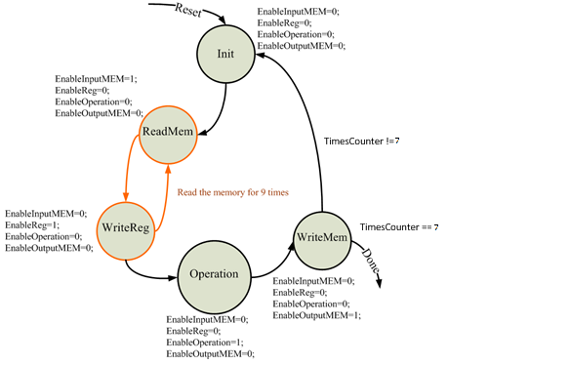

- Input_memory :
  - Modify the IM macro in simplesystem_tb.v to two given test patterns inputmemory_a.dat and inputmemory_b.dat so it can be loaded to input_memory module.

- Write Verilog code for the controller, And you should name all your I/O ports according to Fig1. simplesystem.
- Complete all components related to datapath (simplesystem.v). The input and output ports are already defined in this simplesystem.v. Please follow the specification.
- Compile the verilog code and write a testbench to verify the operations of this module works properly.
- Please attach your waveforms and specify your operations on the waveforms.
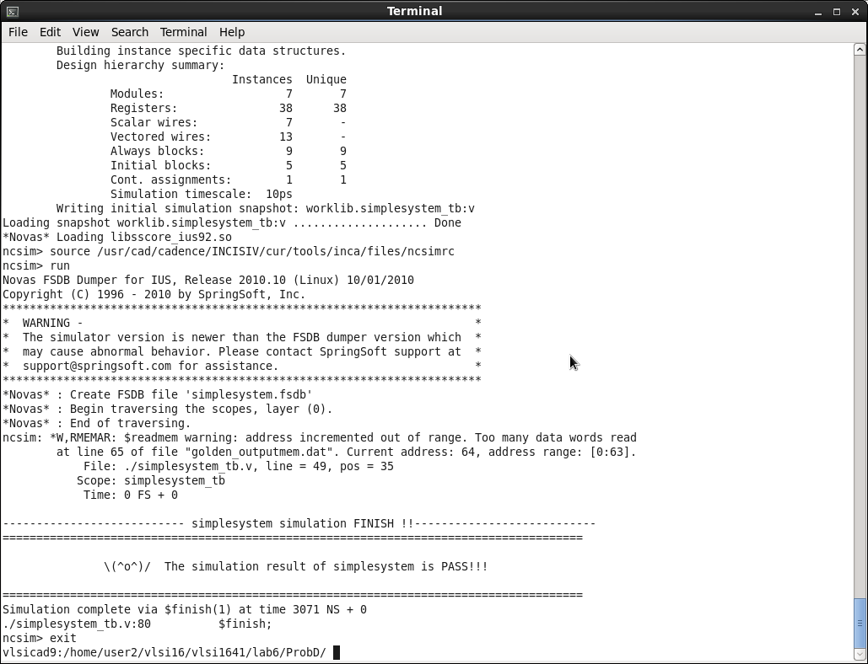
Simplesystem:
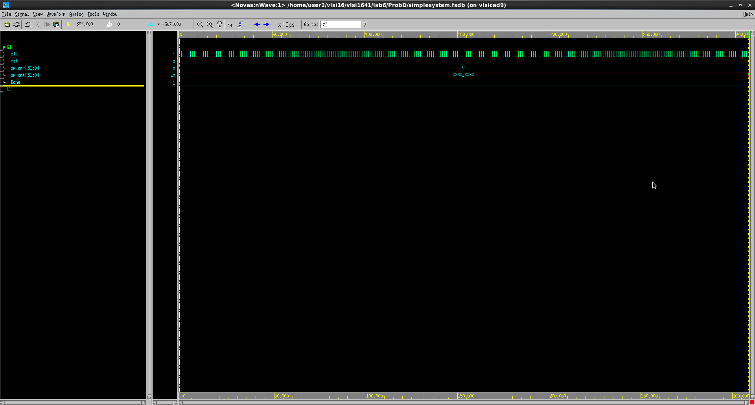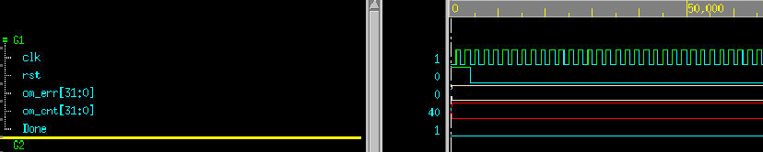
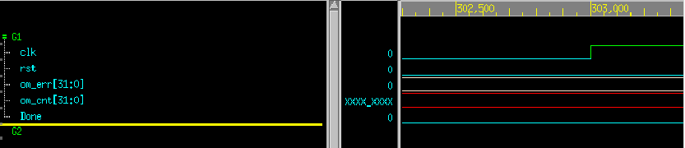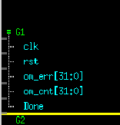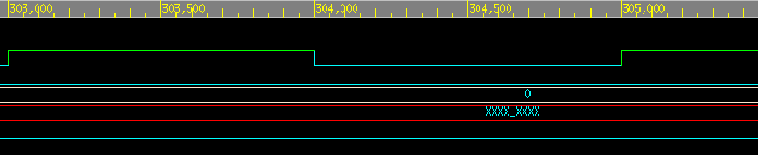
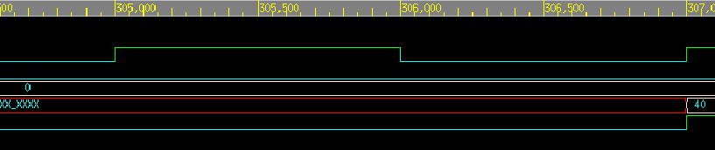
先用reset去重製所有的port
當到時間307時,done為1時,代表已經跑完所有程式的運算

Controller:
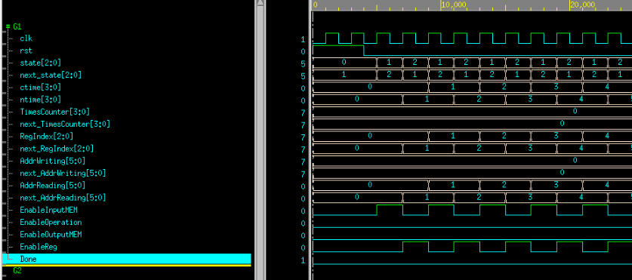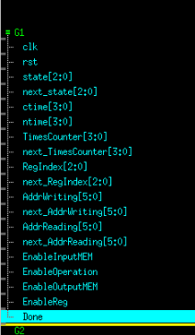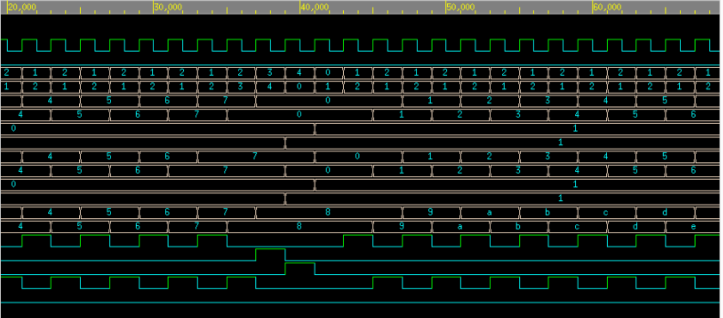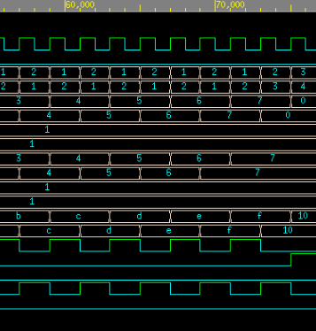
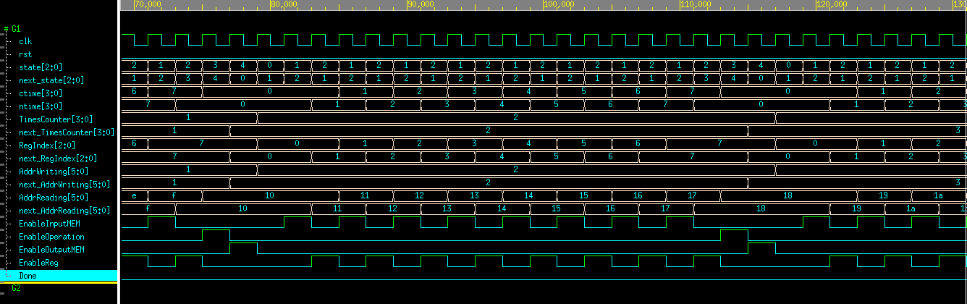
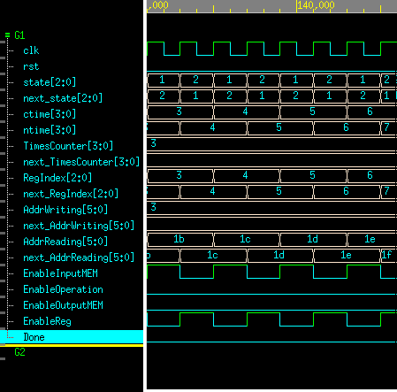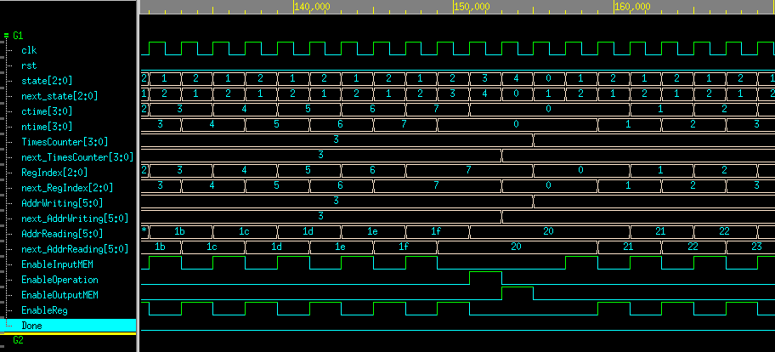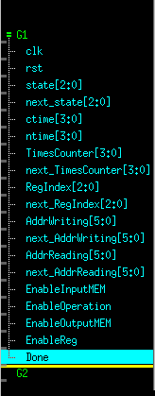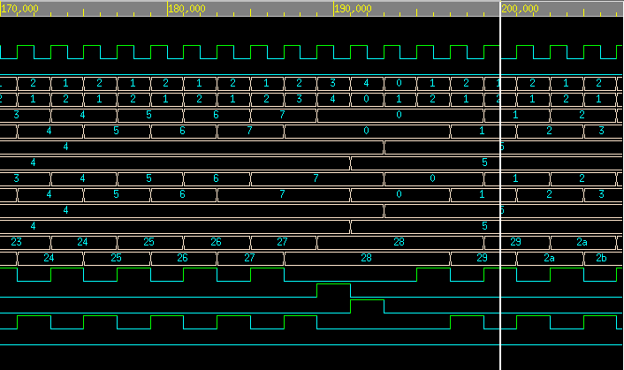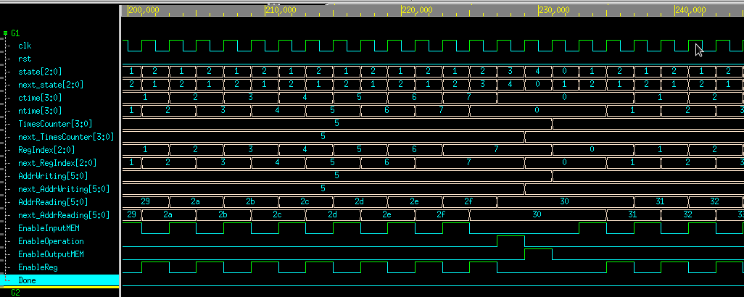
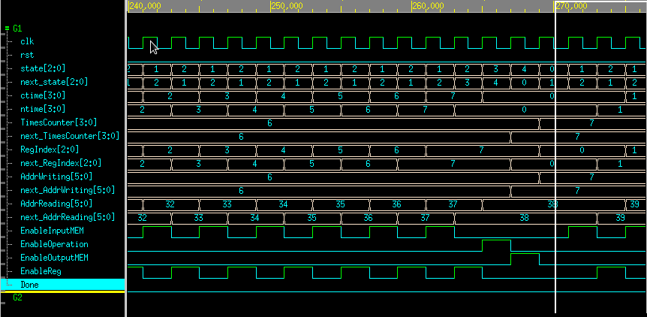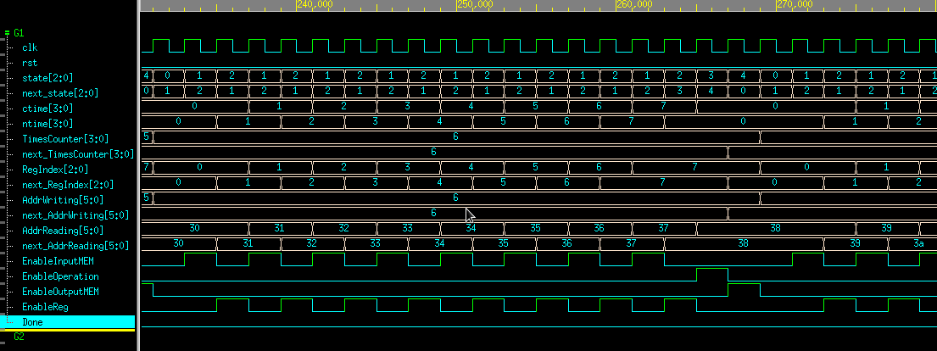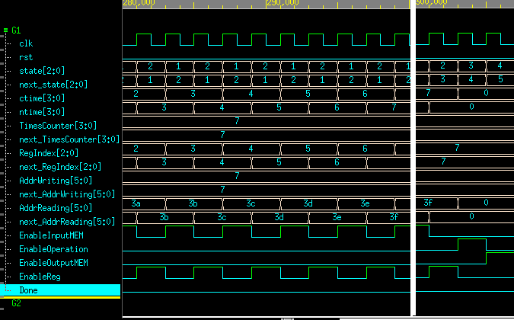

先用reset去重製所有的port
讓state從init去跑到其他state,使之作運算,剛開始會在 state=1與state =2之間跳,要做運算共八次 , 才會到state=3,
還有TimeCounter要為7才會跑完所有程式
AdderReading會隨著read the memory的次數而增加,進入到下個子程式做addr的位置
AdderWriting會隨著TimeCounter的次數而增加, 進入到下個子程式做addr的位置
ctime為read the memory的次數,之後跑完八次會歸零

Input&Output: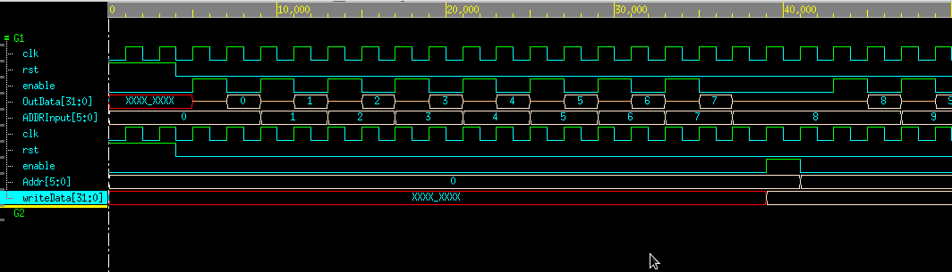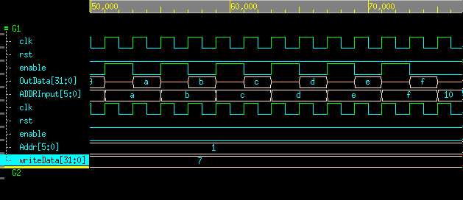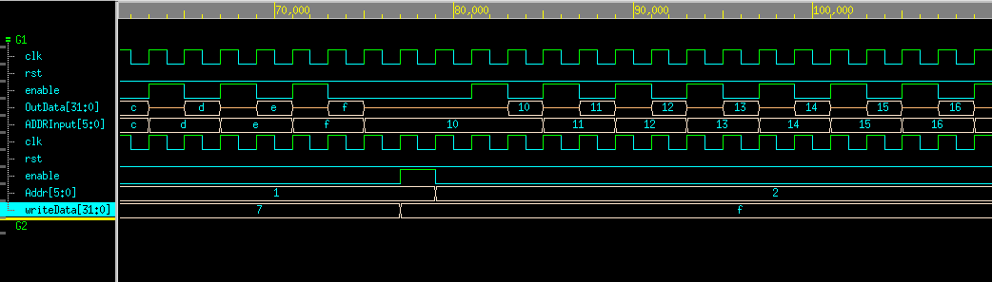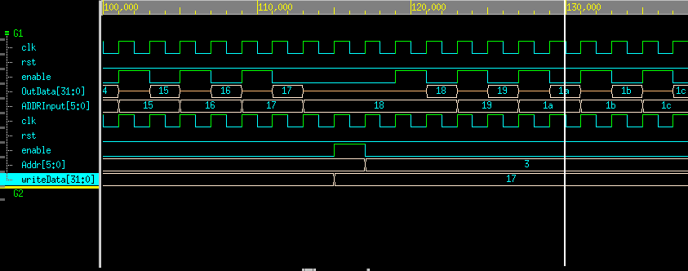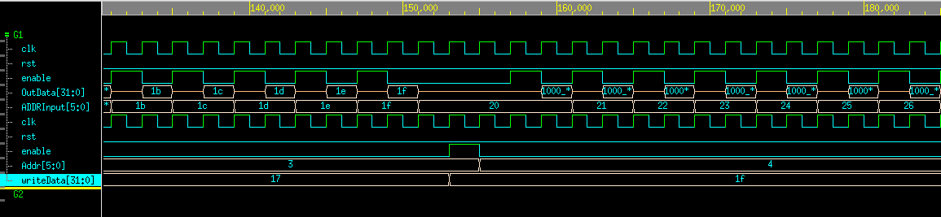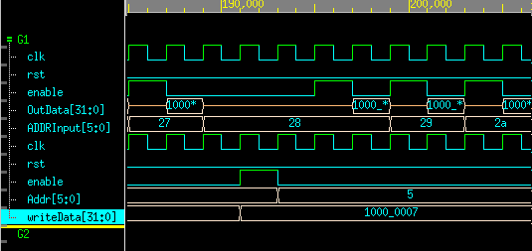
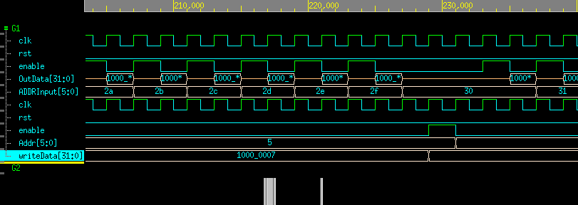
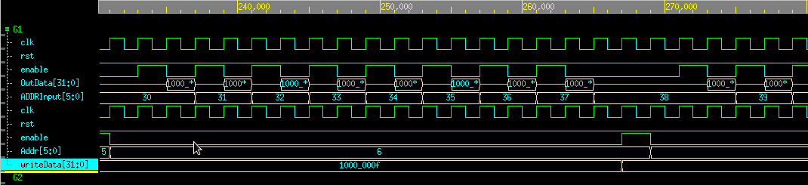
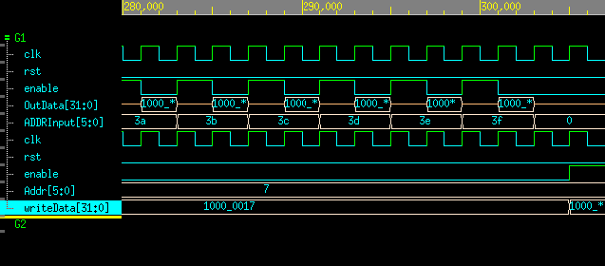
先用reset去重製所有的port
Input:
AdderReading會連接到ADDRInput裡
將所對應的OutData丟出去
Output:
AdderWriting會連接到Addr裡
則從OutResult丟入writeData

Operation&regfile: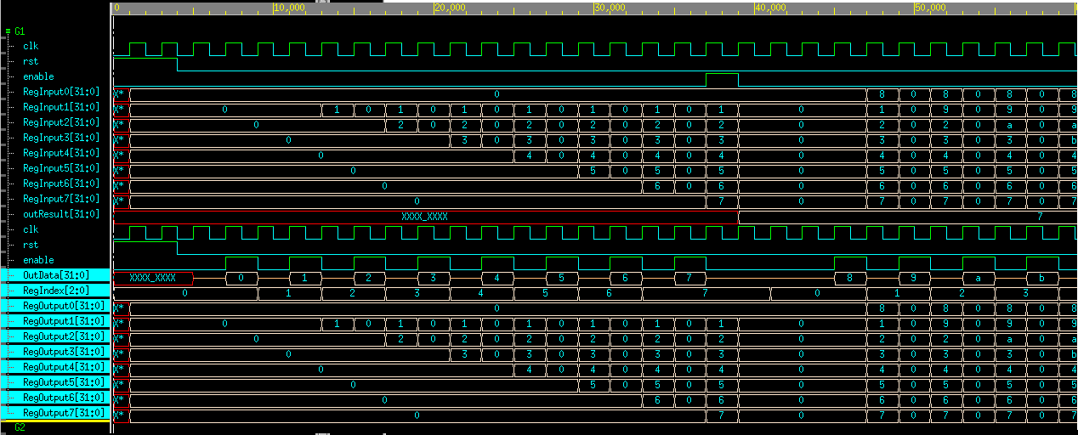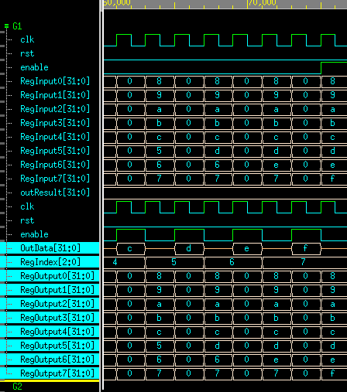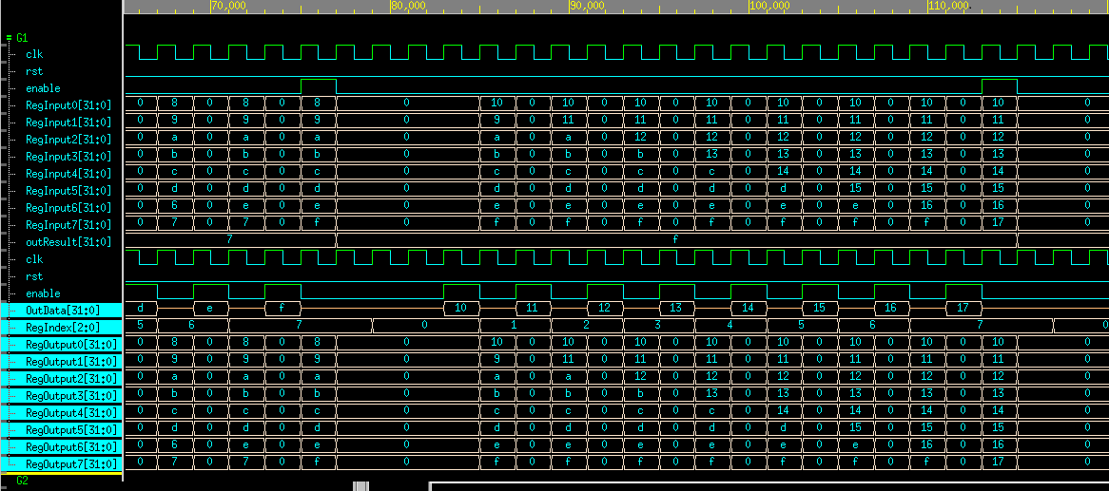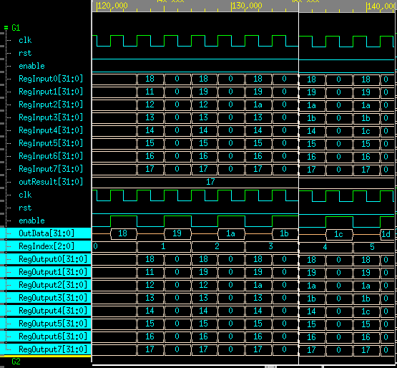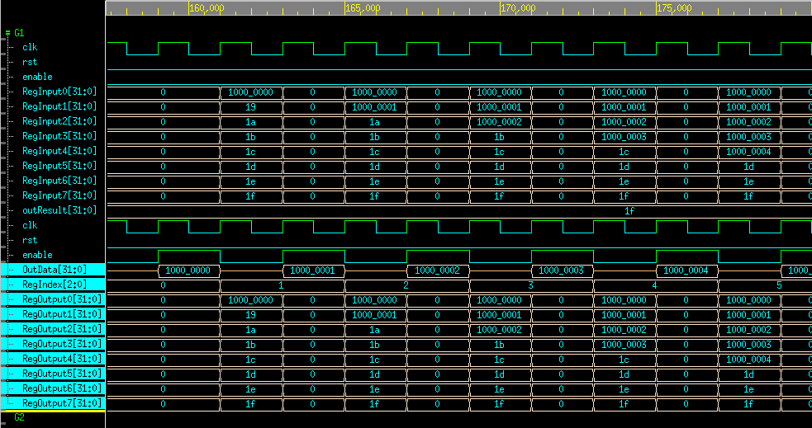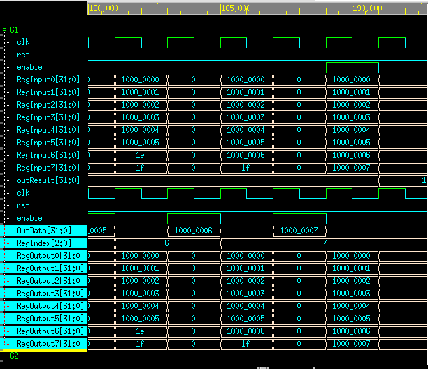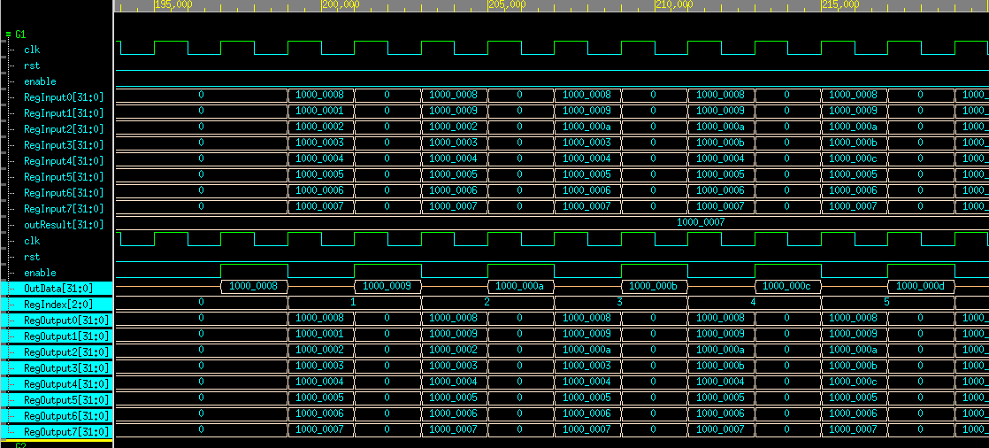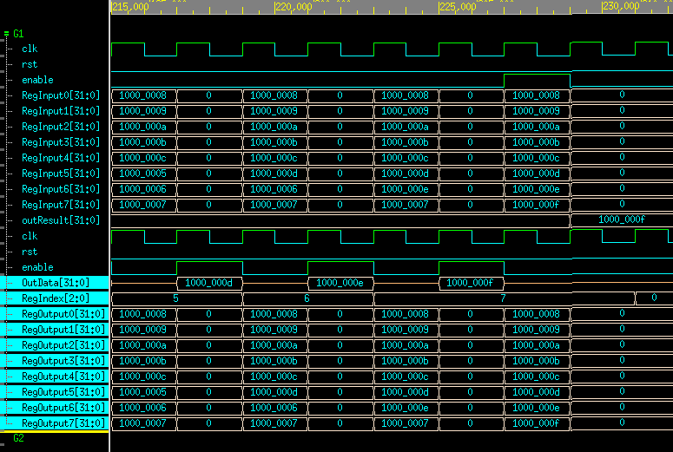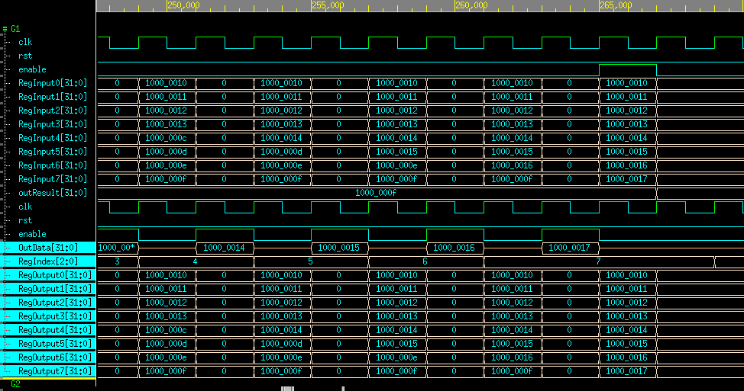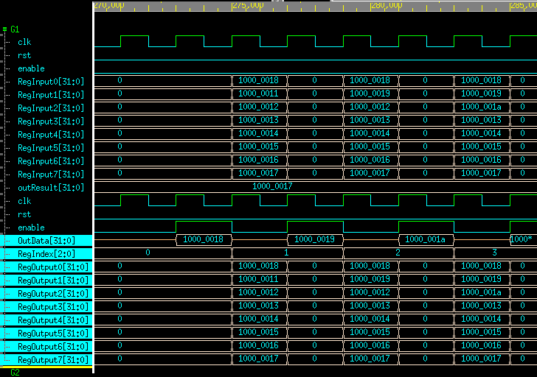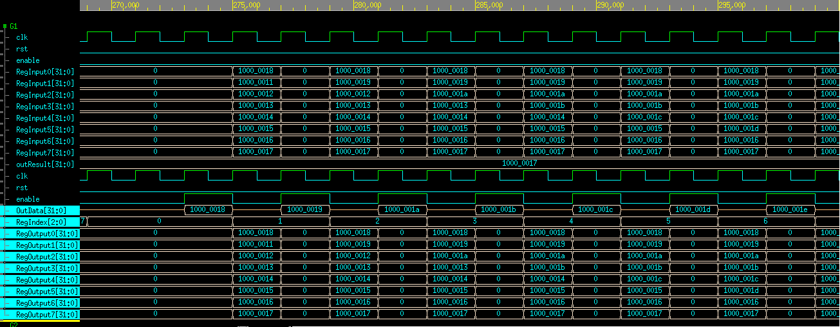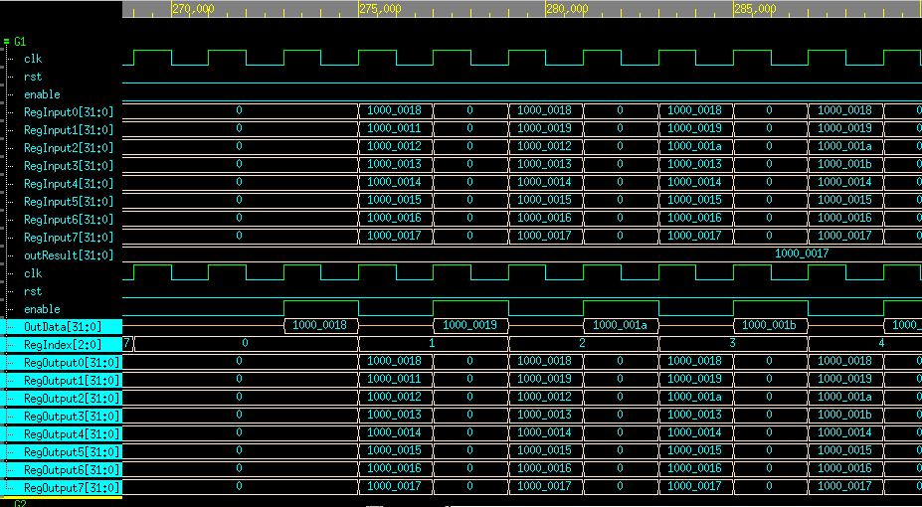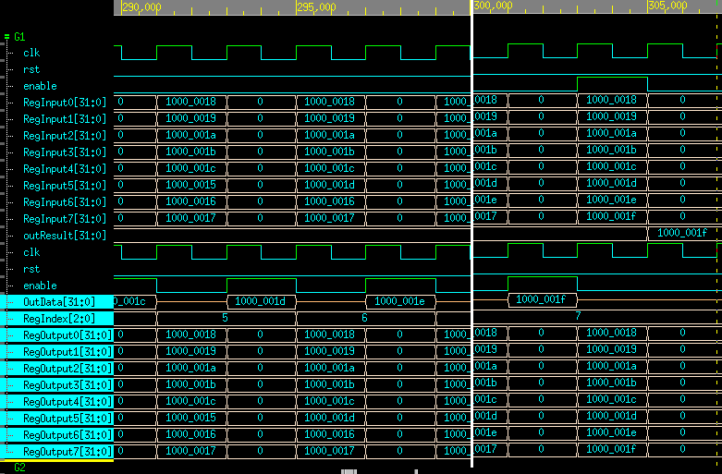
先用reset去重製所有的port
Operation:
從Regfile輸出的8個值去比大小,輸入到RegInput裡面,之後OutResult就會去抓前一個去比較,
Regfile:
從前面得到的RegIndex當作是打開RegOutput的addr,之後再將前一個OutData存入RegOutput

At last, please write the lessons learnd from this lab session, or some suggestions for this lab session, thank you.

Please compress all the following files into one compressed file (“.tar “format) and submit through Moodle website:
a) Verilog codes, testbench and any other files to support your testbench
LabA: oore.v , moore_tb.v
LabB: ealy.v , mealy_tb.v
LabC: (1) RAM.v , RAM _tb.v
(2) input_memory.v, input_memory_tb.v, inputmemory.dat
(3) output_memory.v, output_memory_tb.v

LabD: controller.v
operation.v
regfile.v
simplesystem.v
simplesystem_tb.v,
Input_memory.v
output_memory.v
inputmemory.dat,
inputmemory1.dat
※ NOTE:
1. If there are other files used in your design, please attach the files too and make sure they’re properly included.
2. In Lab D, please include needed file in simplesystem.v. As for simplesystem_tb.v, please modify the defined macros ONLY( TA will use original version of testbench to compile your code).

b) Lessons learned from this lab
這次實驗讓我學到很多東西,從老師上課精彩且詳細的介紹,還有助教詳細的解說實驗,讓我收穫許多,雖然之前有學過如何寫, 但是沒有這次講解的詳細,而且之前也有許多沒注意到的地方,這次就很清楚地避免,這次有要寫出MOORE和MEALY還有RAM等,還有最後的CPU,真的是讓我一個頭兩個大,感覺很複雜 ,讓我想了很久最後才終於寫出來,讓我獲益良多,也感謝助教和教授的指導,讓我抓出許多盲點以及缺失,覺得開心

